CANDIDATE NUMBER:__________________________
NORTHERN EDUCATION DIVISION
2026 MSCE MOCK EXAMINATIONS


PHYSICS
PAPER I
(100 Marks)

Subject number: M164/I
FRIDAY 22, March 2026 Time Allowed: 2 hours
8:00 am – 10:00 am
INSTRUCTIONS:
Question Number | Tick if Answered | Do not write in this column
1
2
3
4
5
6
7
8

9
10
11
12
13

- Write your official name and class on top of every page.
- The paper contains two sections; A and B, on 11 printed pages. Please check.
- In section A, there are 10 short answer questions. While in section B, there are three descriptive questions.
- Answer all the questions in the spaces provided.
- Maximum number of marks for each answer is indicated against each question.
- Use of electronic calculators is allowed.
- In the table provided on this page, tick against the number of the question you have answered.
h). Hand in your paper to invigilator when time is called to stop writing.

SECTION A (70 marks)
- (a) Differentiate between a scalar and a vector quantity.
A scalar is a physical quantity with magnitude only while a vector is a physical quantity with magnitude and direction (1) (1 mark)
b. Why is acceleration a vector?
It uses velocity (1) which is a vector with both magnitude and direction.(1)
(2 marks)
c. Explain one way on how you can minimize a parallax error
Observer should always position the eye perpendicular to the correct value mark (1) (1 marks)
Convert 20Mg to kg
20 x10⁶g (1)
1000g = 1kg
20x10⁶g = xkg
1000x = 20x10⁶ x 1
X = (20 x10⁶)/1000 (1)
= 20000kg (1) (3 marks)
- a. Explain why tractors easily pass through a muddy area without sinking into the ground
Tractors have large/wide tyres (1), this makes their tyres to have a large surface area (1), and this reduces the pressure it exerts on ground (1)
(3 marks)
b. Study Figure 1 below and use it to answer the questions that follows
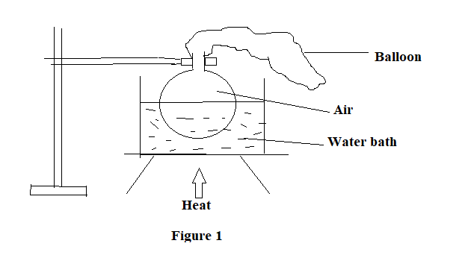
- State what will happen to the balloon when the heat is applied after some time
Inflated/ increase in size /expand. (1) (1 mark)
- Explain your answer in 2b(i)
Heat supplied causes the temperature of the gas molecules to increase hence the molecules moves faster(1), as a result they strike the walls of the balloon with a greater force and frequently (1), hence the pressure on the walls of the balloon increases this makes the volume to increase causing inflation of the balloon (1)
(3 marks)
- a. State Faraday’s law of electromagnetic induction.
States that the induced electromotive force is directly proportional to rate of flux cutting a conductor (1) (1 mark)
b. Figure 2 below is a diagram of a transformer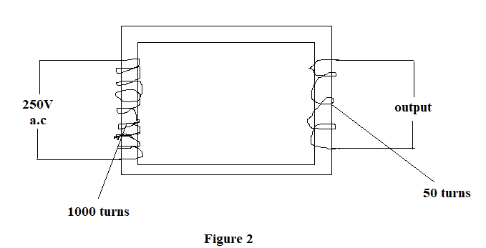
- Name the type of the transformer
Step down (1 mark) (1 mark)
- Give a reason for your answer in 3b(i)
Number of turns in the output/secondary coil is less than the number of turns in the input/primary coil (1) (1 mark)
- Calculate the output voltage of the transformer
$\frac{Ns}{Np}=\frac{Vs}{Vp}$ (1)
$\frac{50}{1000}=\frac{Vs}{250}$ (1)
Vs = (250 x 50)/1000
Vs -= 11.5V (1)
(3 marks)
- State any two ways how the transformer above loses energy
- Hysteresis losses/ Eddy currents/resistance of the coils/flux or magnetic leakages (any 2, one mark for each correct answer) (2 marks)
- a. Explain how temperature affects the speed of sound in air
Increase in temperature increases the speed of sound (1)
Since increase in temperature causes the gas molecules to gain kinetic energy and move faster this makes the molecules to transmit sound waves much faster (1) (2 marks)
b. State any one factor that affects the frequency of a cantilever
Mass on the cantilever
Length of the cantilever
Mass loaded on the cantilever
Stiffness of the cantilever (any 1) (1 mark)
c. Figure 3 is a diagram of a wave
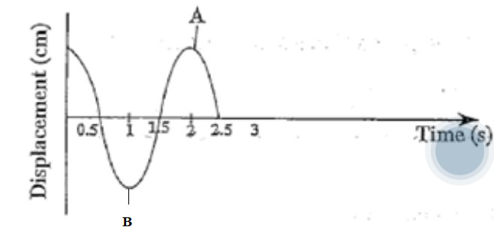
Figure 3
- Name the type of the wave given in figure 3.
Transverse wave. (1 mark) (1mark)
- Calculate the frequency of the wave
Frequency = No of complete cycles/ time taken (1) = ½
= 0.5Hz (1) (2 marks)
- Determine the velocity of the wave if its wavelength is 100m
Velocity = frequency x Wavelength (1) = 0.5Hz x 100m
= 50m/s (1) (2 marks)
- a. Explain how the radio waves are detected
Detected by aerials/diodes/ear phones in electric circuits (1) because they cause a small electric current to flow in electrical circuits (1) (2 marks)
b. Figure 4 below is a diagram of a person reading a book
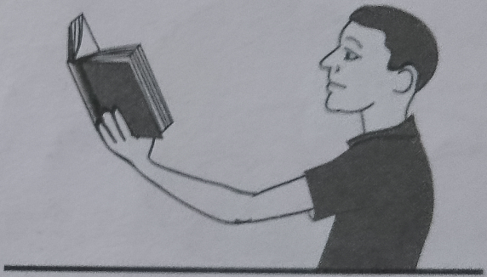S
Figure 4
- Name the defect shown in figure 4
Long sight/Long sightedness/Hypermetropia (1 mark)
- Explain how the defect in figure 4 occurs
Occurs when a person has a short eyeball/weak focusing power of the cornea/curvature of the cornea being defective (1), this causes the light rays to converge behind the retina instead of the retina (1), resulting into a blurry vision for nearby objects/objects very close (1) (3 marks)
- State one way in which the defect can be corrected
Using glasses containing convex/converging lens (1 mark)
- a. Differentiate the term Nuclear Fusion from nuclear fission.
Nuclear fusion involves combination of lighter nuclides while Nuclear Fission involves splitting of larger nucleus. (1 mark)
b. Mention any one characteristics of radioactive materials
- specific half life
- have unstable nuclide
- decays to release radiations ( any one for 1 mark)
(1 mark)
c. The tyre of the bicycle rotated with angular velocity of 65.5rads/sec. Find tangential velocity in km/h on the edge of the tyre with radius 45cm
V = rɯ (1)
= $\frac{45 x 65.5}{100}$ m/s (1)
= 29.475m/s to km/hr
= $\frac{29.475 x 3600}{1000}$ km/hr (1)
= 106.11km/hr (1) (4 marks)
- Figure 5 shows a coin and a feather falling through a vacuum
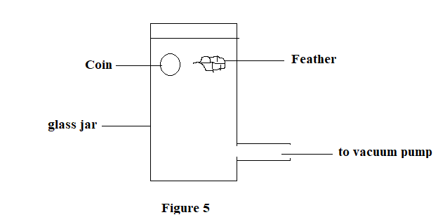
- Which object(s) will reach the bottom of the tube faster, if they were both released at the same time
both (1) (1 mark)
- Explain your answer in 7(a) above
They do not experience air resistance (1), hence they fall with only the acceleration due to gravity (1) (2 marks)
- Give two reasons why water is not used in hydraulic machines
    - Corrode the system
    - Does not have wider temperature
    - Lacks lubrication properties. (2 marks)
- a. Explain how a short circuit occurs
occurs when a bare live wire touches a bare neutral wire (1), this creates a large current to flow between the live wire and the neutral wire (1) hence causing a spark (1)
(3 marks)
b. (i) Define the term “internal resistance of a cell”
Small resistance the chemicals of a cell offers to the flow of current inside it (1 mark)
(ii) The potential difference across the terminal of a cell is 1.5V when there is no current in the cell. When there is a current of 0.2A in the circuit, the potential difference falls to 1.4V. Calculate the internal resistance of the cell
Emf = 1.5V
Terminal Voltage = 1.4V
Lost voltage 1.5V – 1.4V = 0.1V (1)
V = Ir (1)
0.1 = 0.2r (1)
r = 0.1/0.2
= 0.5Ω (1) (4 marks)
- a. Figure 6 below is a diagram showing radiations passing through a magnetic field
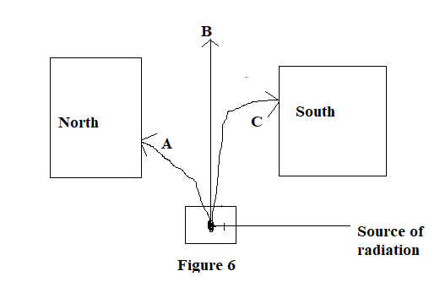
- Name the particle labelled A
Beta particle (1) (1 mark)
- Explain why particle C deflects towards the south
Because of their interaction with the magnetic field (1), have positive charge(1) hence experiences a magnetic force that directs them to the south pole (1) (3 marks)
b. Explain why it is important to use radioisotopes with a shorter half-life as tracers in agriculture
decay rapidly/quickly (1), resulting in a minimal damage for plant cell/reducing risk of long term contamination (1) (2 marks)
- Figure 7 below shows a symbol of a logic gate, use it to answer question that follows
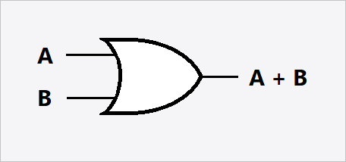
Figure 7
- Name the logic gate given in figure 7 above.
OR gate (1)
(1 mark)
- Draw the truth table for the working of the logic gate named in (a)
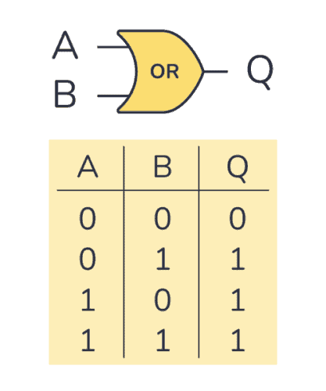 (2 marks)

  - Figure 8 is a diagram of an instrument used to measure gas pressure. Use it to answer the questions that follow.

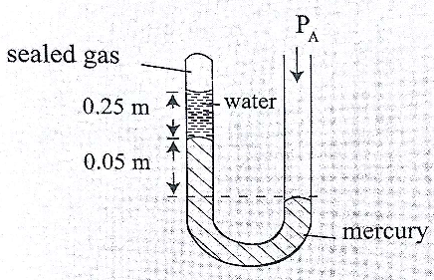figure 8

- Name the instrument.
- U - tube manometer (1)
ii. If the atmospheric pressure P_{A} is 102000N/m², density of mercury is 13600kg/m³ and g = 10N/kg, calculate the pressure of the trapped gas. (Take density of water as 1000kg/m³.
Pressure exerted by a column of water = dhg
= 1000 x 0.25 x 10
= 2500N/m² (1)
Pressure exerted by a column of mercury = dhg
= 13600 x 0.05 x 10
= 6800N/m² (1)
Gas pressure =atmospheric pressure – pressure due to liquid column
= 102000N/m² – ( 2500 + 6800)N/m²) (1)
= 102000N/m² – 9300N/m²
= 92 700N/m² (1)
(4 marks)
SECTION B (30 MARKS)
- a. Describe how you can measure the internal diameter of a small plastic tube
- The plastic tube is placed between the outside jaws of the vernier calliper (1)
- The jaws are closed using the inside jaws (1)
- read the main scale and record the value (1)
- identify a mark the mark on the vernier scale which coincides exactly with a mark on the main scale and record its reading (1)
- add the two readings (1) (5 marks)
b. With the aid of a well labelled diagram, explain how the Newton’s third law of motion can be applied in agricultural irrigation in Malawi
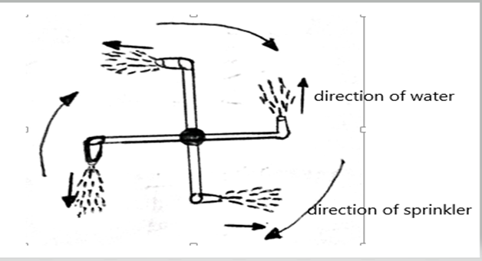
1 mark for correct diagram and correctarrows
- This is applied in irrigation when using sprinklers. (1)
- Water moves out forward direction (action) (1)
- and sprinkler moves back (reaction) (1)
- The sprinkler rotates in the direction opposite to that of the water jet. (1)
(5 marks)
- a. Describe how you can demonstrate atmospheric pressure using a collapsing can experiment
- put some water in a large can/bottle (1)
- boil off the water in the can and immediately cork the can (1)
- allow the can to cool and observe what happens (1)
- the can crushes/collapses (1) since the pressure inside the can is less than the pressure outside the can (1)
- this shows that air exerts pressure (1) (5 marks)
b, Using a well labelled diagram describe the destructive wave interference

+ = ______________ (1)
2 marks for diagram (1 mark for correct diagram each side)
- occurs when identical waves meet out of phase/ occurs when a crest meets a trough (1)
- this results in cancellation amplitude (1) (4 marks)
- Using a well labelled diagram, Describe an experiment that you could use to determine the acceleration due to gravity using a simple pendulum

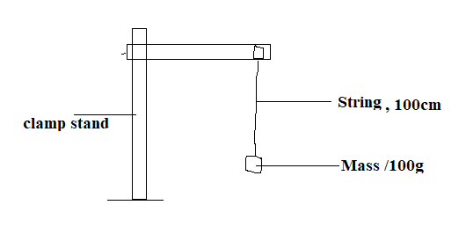 2 marks for correct diagram, 1 mark for 2 correct labellings
- Set up the experiment as shown above (1)
- Pull the mass sideways with a small amount and release it to oscillate, start the stopwatch (1)
- Note and record time taken for 20 oscillations in the table (1
- Repeat the steps for other length of the pendulum (1)
- For each length determine its periodic time and square it (1)
- Draw a graph of T² against L (1)
- Determine the value of the gradient/slope(1)
- Calculate the value of acceleration due to gravity (1) (10 marks)

